MONDAY | TUESDAY |  | WEDNESDAY |  | THURSDAY | FRIDAY | ENROLMENT
Hastings Happy Crafters  Time: 10.00-11.30am  All year activity  $4.00 per session.  This active craft group will inspire you to create by sharing skills and undertaking craft projects. All abilities welcome. We have craft supplies here to share or bring your own project. Commencing Mon 05th Feb | Hastings Hot Trotters  Time: 9.00-1.00pm  All year activity  FREE.  Meet @ Pelican Park  Laughs conversation and exercise taking in various locations around Western Port.  Call Denise on 0439 837 691 for more details. |  | 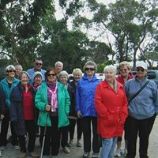 |  | Community Cooking  Time: 10.30- 1.00am  On Thursday’s we cook and prepare meals to supplement our Wednesday free food program. Meals made from reclaimed and donated food items. Volunteers needed. Contact us for further details. | ***New Foreshore Friends Community Playgroup***  Time: 9.00–11.15am  Gold Coin Donation  All parents & caregivers with children under 4 yrs. welcome.  Commencing Fri 09th Feb | How to Enrol:  CONTACT: PH: 5971 9198  Email:hastingsch@bigpond.com  Or: FB Messenger  In person during office hours:  9.30-3.30pm Monday-Friday.  185 High St Hastings.  Left hand car park entrance  We aim to provide low cost classes everyone can participate in. If finances are a concern for you, please talk to our manager, in confidence, to make other arrangements.
Monday Muso’s  Time: 1.00-5.00pm  Come along and have a jam with other musically minded folk. $4.00 per person.  Check out the muso’s @ the FB page!  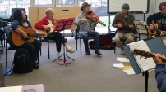  MondayMuso@HastingsCommunityHouse | Yoga & Meditation  Time: 10.30-12.00pm  Cost: $7.00 per session.  Join our qualified instructor in an all-abilities yoga class followed by a relaxing meditation weekly on Tuesday’s. |  | Free Food Wednesday  Time: 3.00-4.15pm  Thanks to Oz Harvest, we now have a selection of fresh fruit, veggies, meat & other goodies available on Wednesdays.  No appointment or health care card needed. Please bring along a reusable cloth/plastic supermarket bag.  ***All Welcome*** |  | Italian for all  Time: 9.00-8.00pm  Learn Italian like a local with our acclaimed tutor Rosella. Select classes throughout the day Rosella provides individual and group classes as well as online sessions. Immerse yourself in the language, culture & food od Italy! Call 0416 341 143 to discuss your needs. | Hastings Toy Library Sessions  Time: 10.30-12.00pm  Our very popular toy library interactive sessions will continue in 2024.  Dates to be advised end of Jan.  Open to all in the community, these sessions complement our playgroup and will run monthly. Structured fun for littlies 0-4years. FREE.  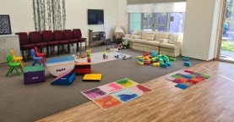 | Forms, Resumes, Cover Letters, Online Applications, Legal Matters.  If paperwork is getting you down, or you need assistance with updating your resume, writing a dynamic cover letter or completing an online application, we can help....Contact us to book a time.  COST DONATION
Breast Feeding Clinic run by Peninsula Health meets Friday’s @ the House  Time: 1.00-5.00pm  Contact the team on:  (03) 9784 2600. | U3A Hastings Classes@ Community House  Time: 1.00-3.00pm  German Conversation  Time: 3.00 -4.30pm  Italian Conversation  Call:  59 79 8585 to enrol. |  | Western Port Neighbourhood Watch  meet @ Community House monthly  contact FB www.facebook.com/WesternPortNHW |  | 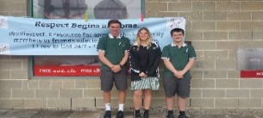  We support the Hastings Respectful Relationship Group in promoting healthy respectful relationships across Western Port. Ask us how you can get involved. | Hastings Community House Breakfast Club  operates 5 days a week from 8.30-9.30am from Hastings Primary School kitchen. Serving toast, pancakes & fruit to the Hastings PS kids during the school terms. If you would like to donate to this program please contact the House. | 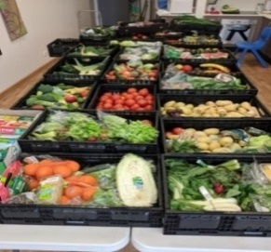  We value and thank our food relief sponsors: Oz Harvest Melb & Woolworths Hastings & Community donations who assists us with reducing food insecurity and accessibility weekly in our community.
.

Check out our new website @  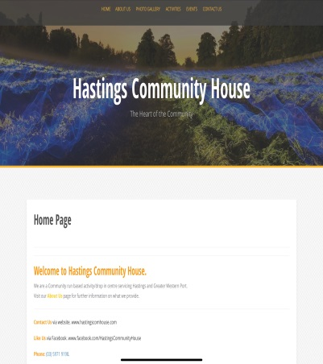  www.hastingscomhouse.com  The following services are available @ Hastings Community House:  Asuria- Assured People Services. Asuria works with employee’s ad governments to find long-term employment. 1800 773 338  @ Wed Thru Fri | 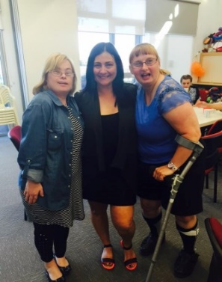  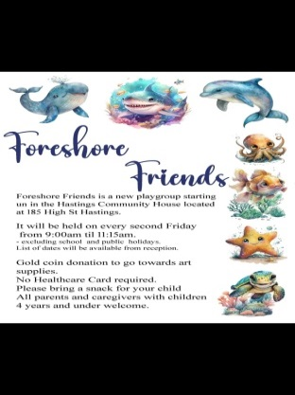 | 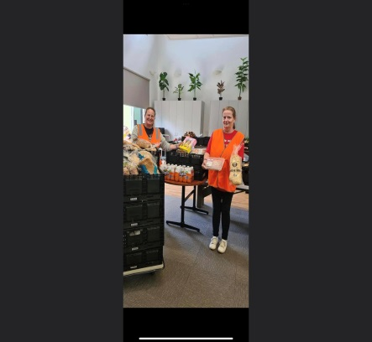  Our volunteers are essential to the successful running of our weekly programs. Each week 16 people provide 79 hrs of volunteering to assist our programs.for more information about volunteering contact us or check out:  https://www.mornpen.vic.gov.au/Community-Services/Volunteering  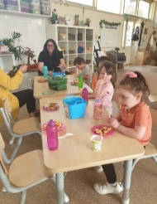  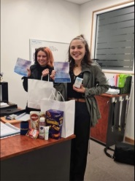  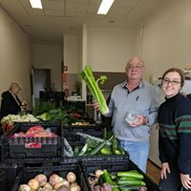 | Hastings Community House  TERM 1  30 Jan – 28 March 2024  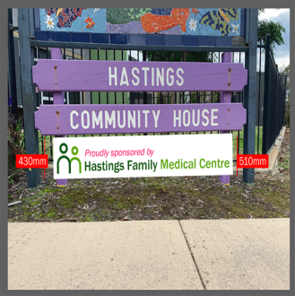  Peninsula Health Complex  185 High St Hastings 3915  Melways Ref: 154 F11  PH: 5971 9198  Email: Hastingsch@bigpond.com  Website: www.hastingscomhouse.com  www.facebook.com/HastingsCommunityHouse  Hastings Community House is Proudly Sponsered By Hastings Family Medical Centre.  Serving soup61 & smiles across Westernport
 |  | Seniors Playgroup. A time out session for adults to chill and relax with some favourite group activities. Cryptic crosswords, mah-jong, chess or maybe just a quick book club discussion, Senior playgroup is all about relaxing your way.
 |  | EXPRESSIONS OF INTEREST SOUGHT
Soapbox Supper Presenters.
Mum’s n Bubs Playgroup.
Op Shop Tour Trip Ideas.

